**Q.3 Demonstrate the installation process of Truffle suite and display the current version of Truffle installed in your Computer.**

**Answer:**

Installation of Truffle:

For installing Truffle in your personal computer, first we need to open command prompt.

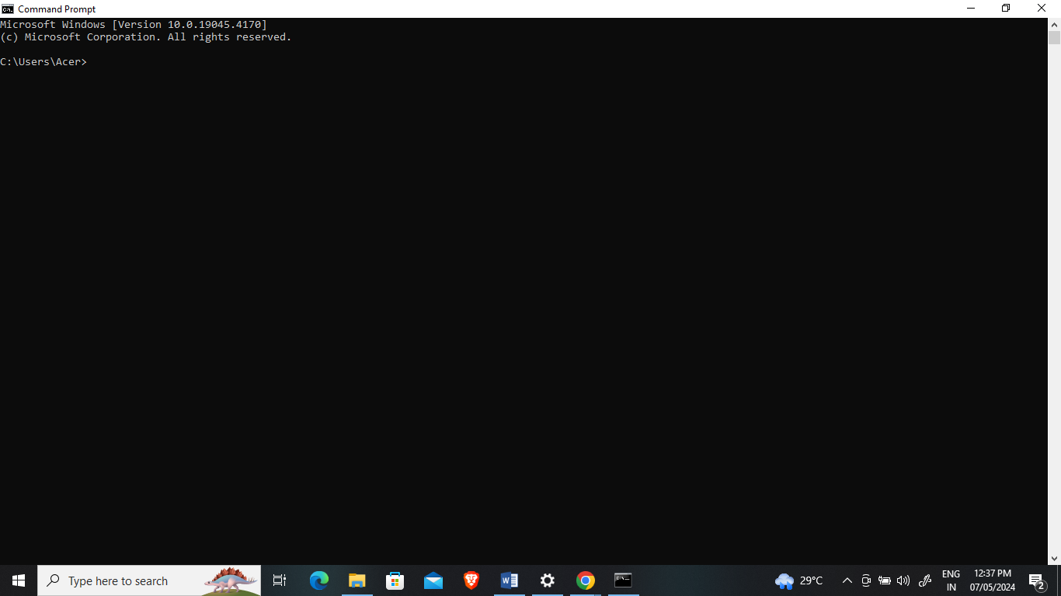

Next run the below command:

**npm install –g truffle**

**-g** refers that we are installing this truffle package globally.

After running the above command your installation process will start like shown below.

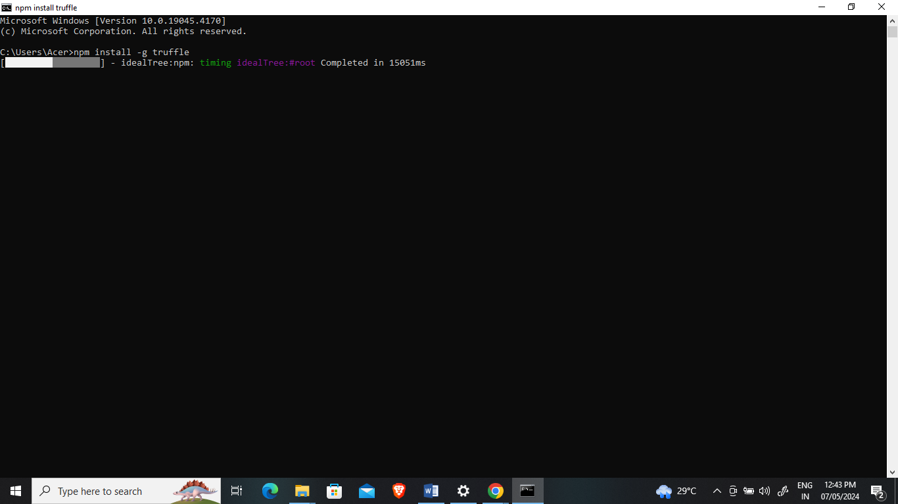

To check wheather Truffle package is installed or not, we need to run the below command:

**truffle version**